1.
Prove by mathematical induction.

2.
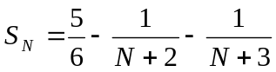 , 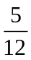

3.
Prove by mathematical induction

4.
(i) 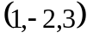
(ii) 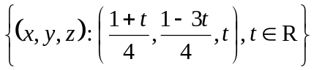

5.
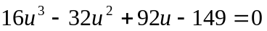

6.
(i)   